  Who we are
  Headley Down Nature Reserve Trust was formed in 2016 by a small group of Headley Down Residents. The reserve is situated adjacent to the Heatherlands Estate playing fields and backs onto the Land of Nod. It is about 2.5 acres of council land that had been abandoned to invasive undergrowth and flytippers.
  The Trust have leased the land and are transforming this former landfill site into a haven for native wild flora and fauna for everyone to access and enjoy.
  Contact Us
  Tel: 07501 872020
  Email: headleydownnaturereserve@gmail.com
  Web: https://www.headleydownnaturereserve.org.uk/
  Find us on social media too!
  Facebook: Headley Down Nature Reserve
  Twitter: @HeadleyNature
  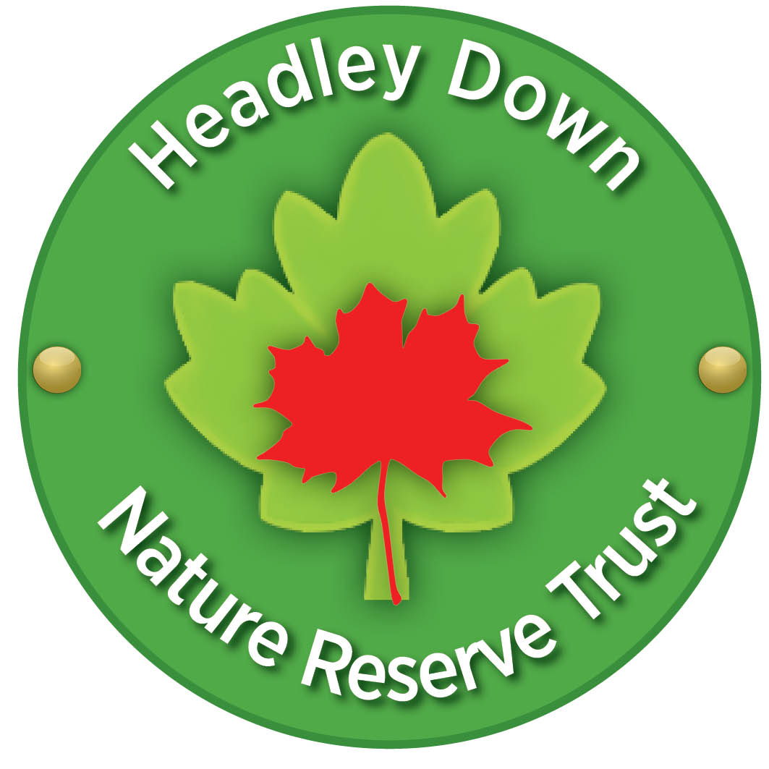
  Instagram: @headley_down_nature_reserve
  Scavenger Hunt
  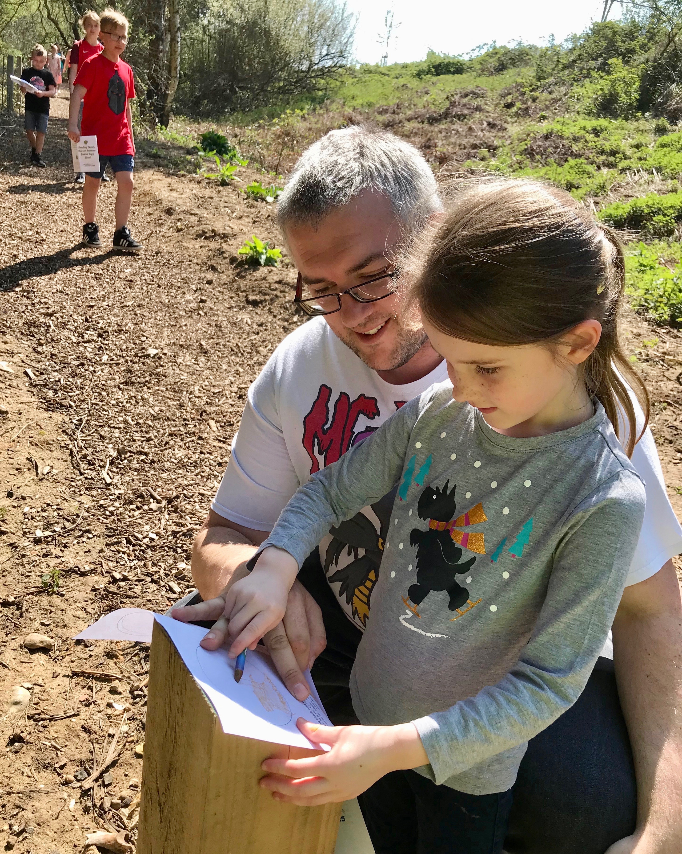
  Headley Down nature reserve
Search around the nature reserve and see what you can find.  Once you have found it, put a tick in the box, when you have found as many things as you can, find a volunteer for your prize!  Don’t forget to tag us in a picture of yourself on Instagram @headley_down_nature_reserve #HeadleyDownNatureReserve #ScavengerHunt  An owl hint: real owls are only seen at night, but the nature reserve has its very own owl you can see all day  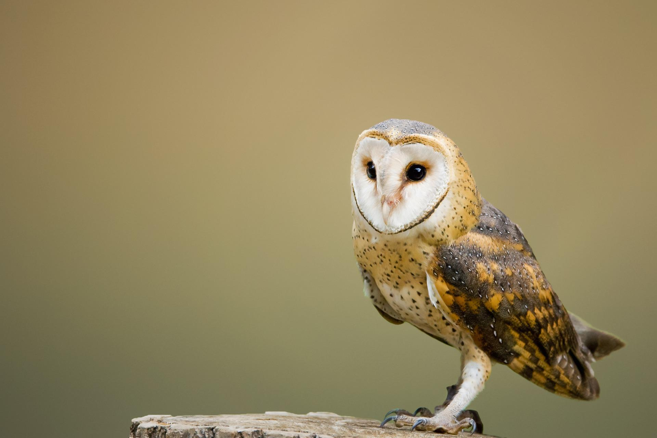  Somewhere to sit  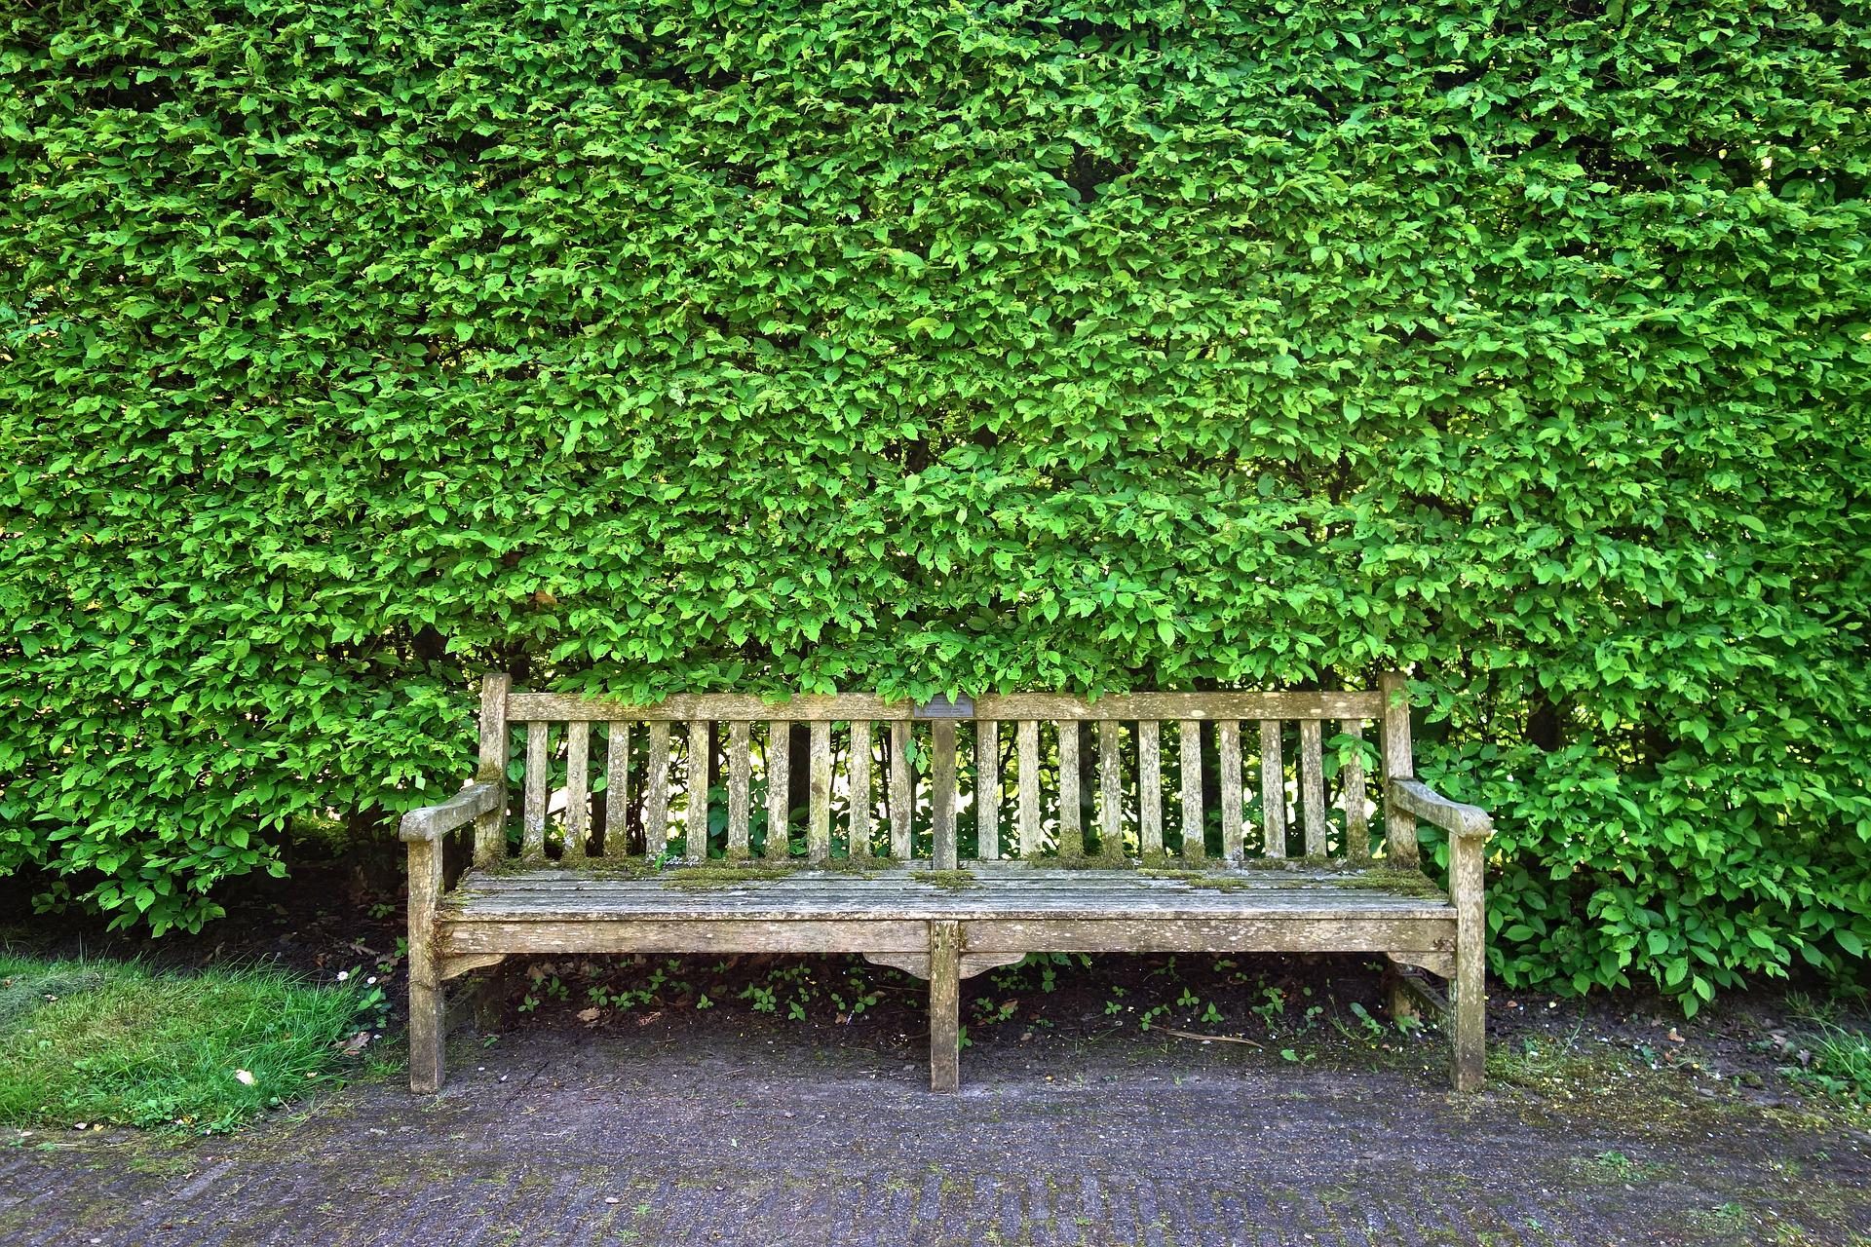 |  |  |  | A bit more extra space…
 |  |  |  | 5

Here is space to find your favorite rubbing posts on the nature trail.  Take a pencil and colour over the post to transfer the image to your paper. Can you find all 12? |  |  | A bee  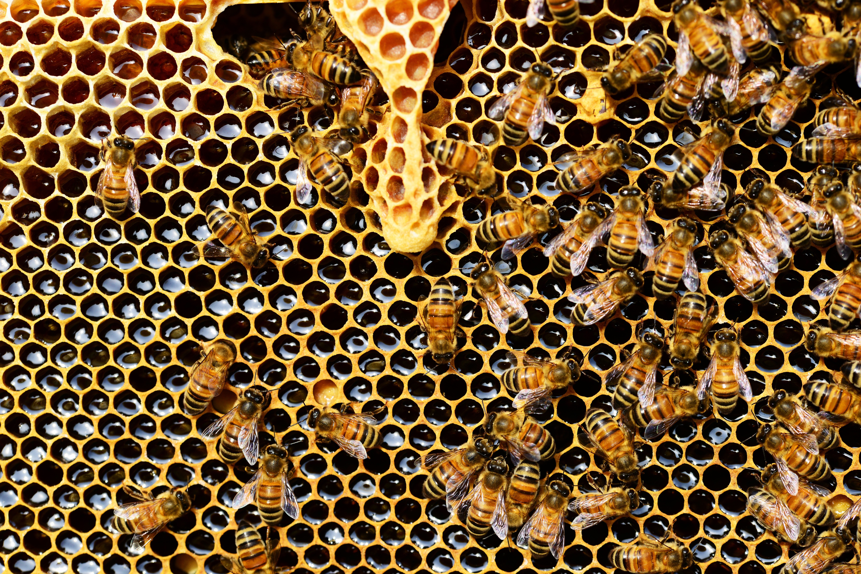  A bird box  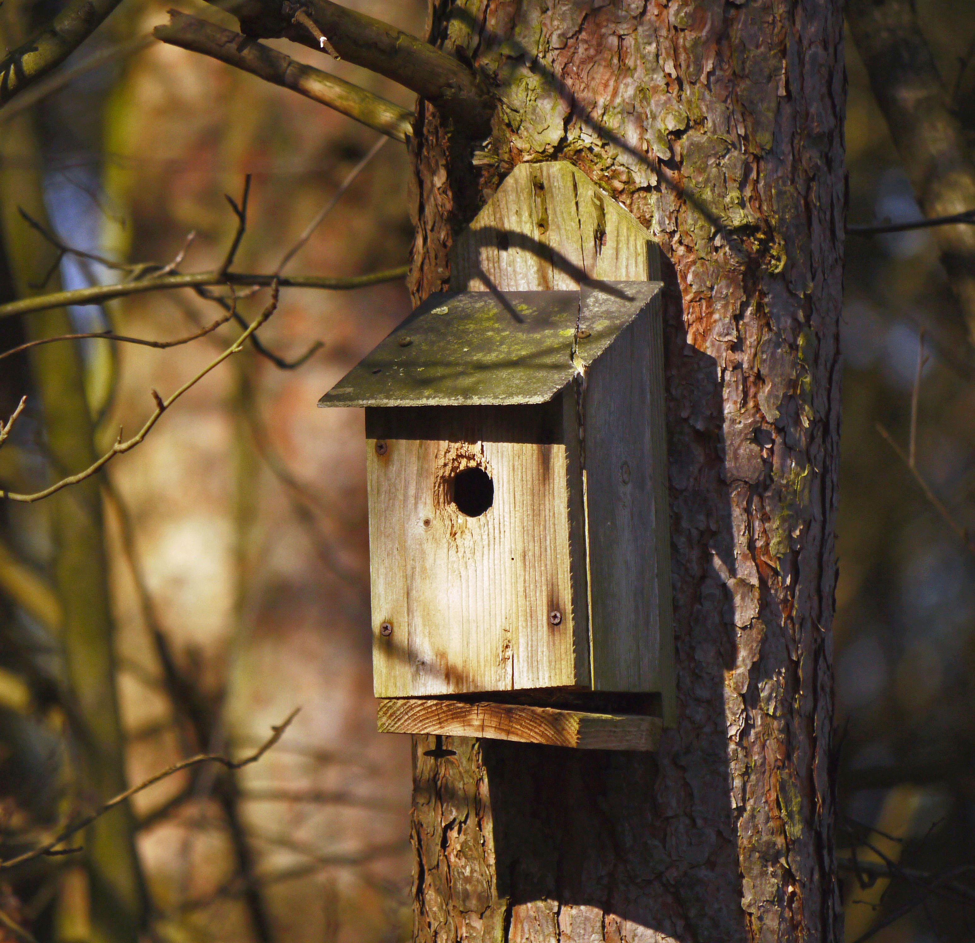  Heather  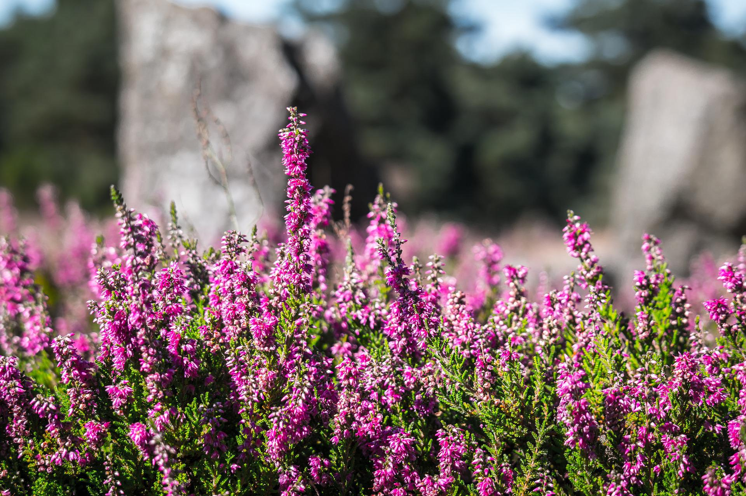
  Badger | Red Kite
  Roe Deer | Toad
  Bumblebee | Great tit
  Butterfly | Grey squirrel
  Fox | Pipistrelle Bat
  Roe Deer | Wren
4 |  |  | 1

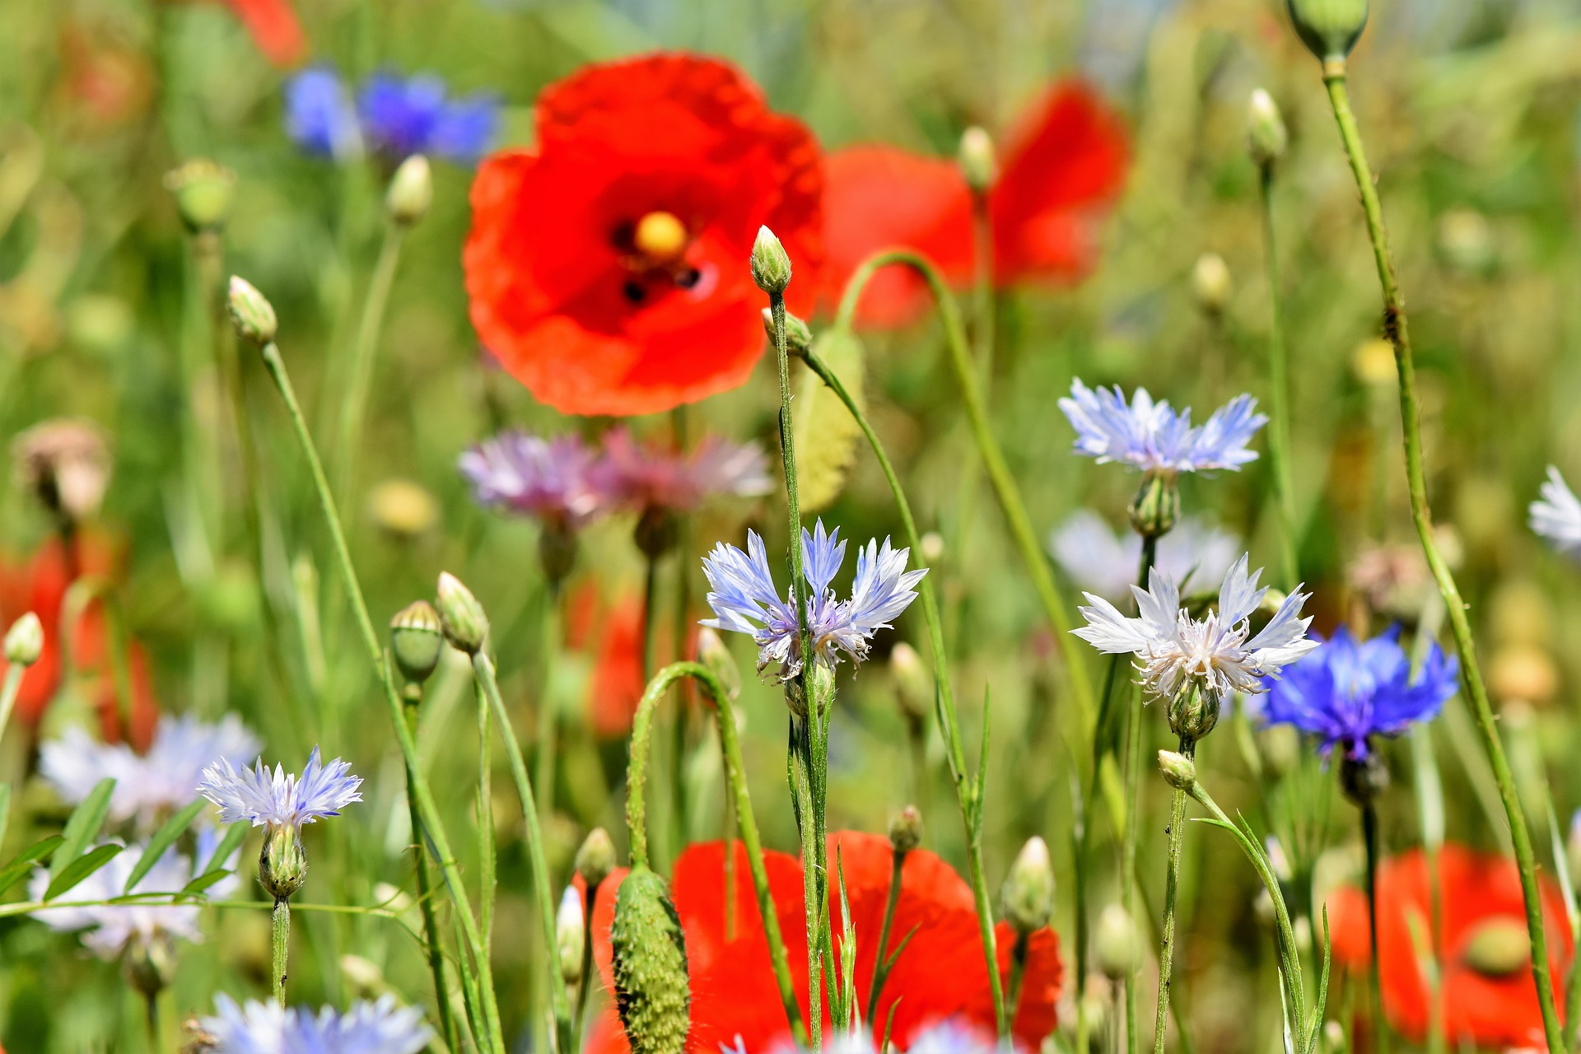  Wildflowers  A butterfly  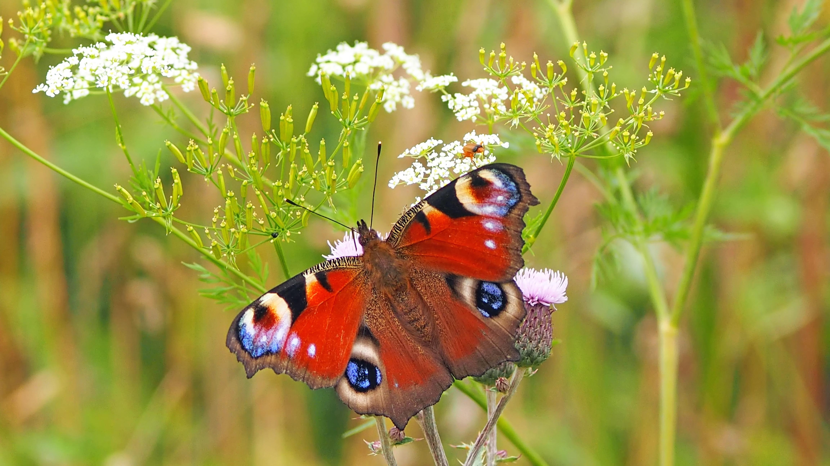  A bird feeding station  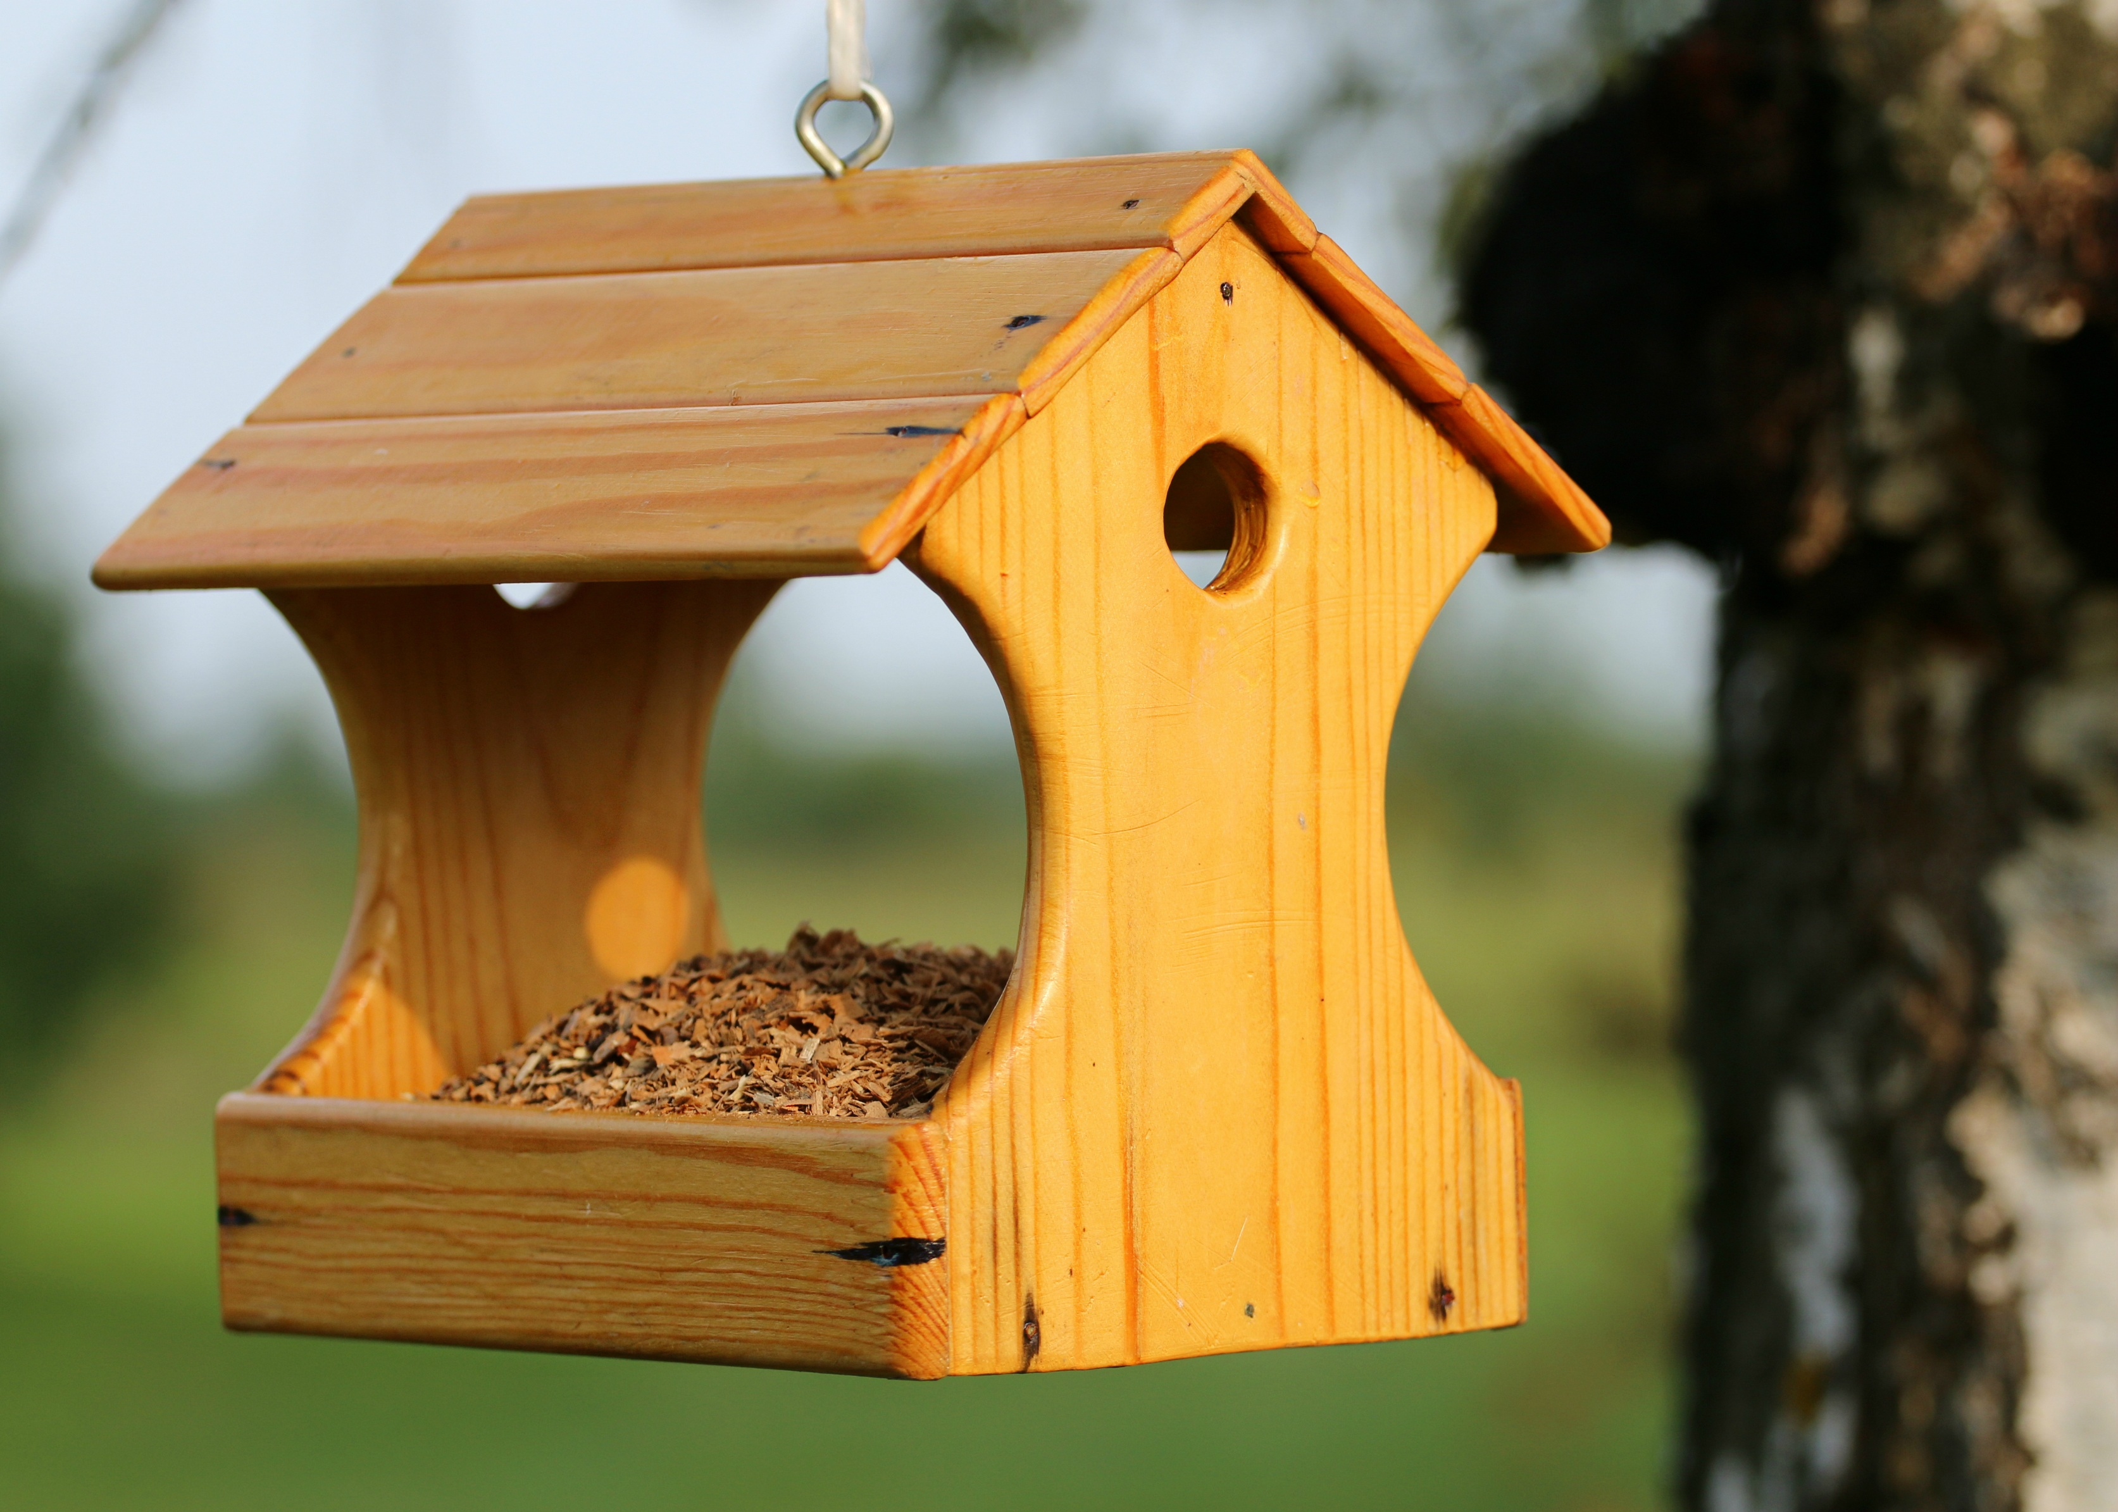 |  |  | 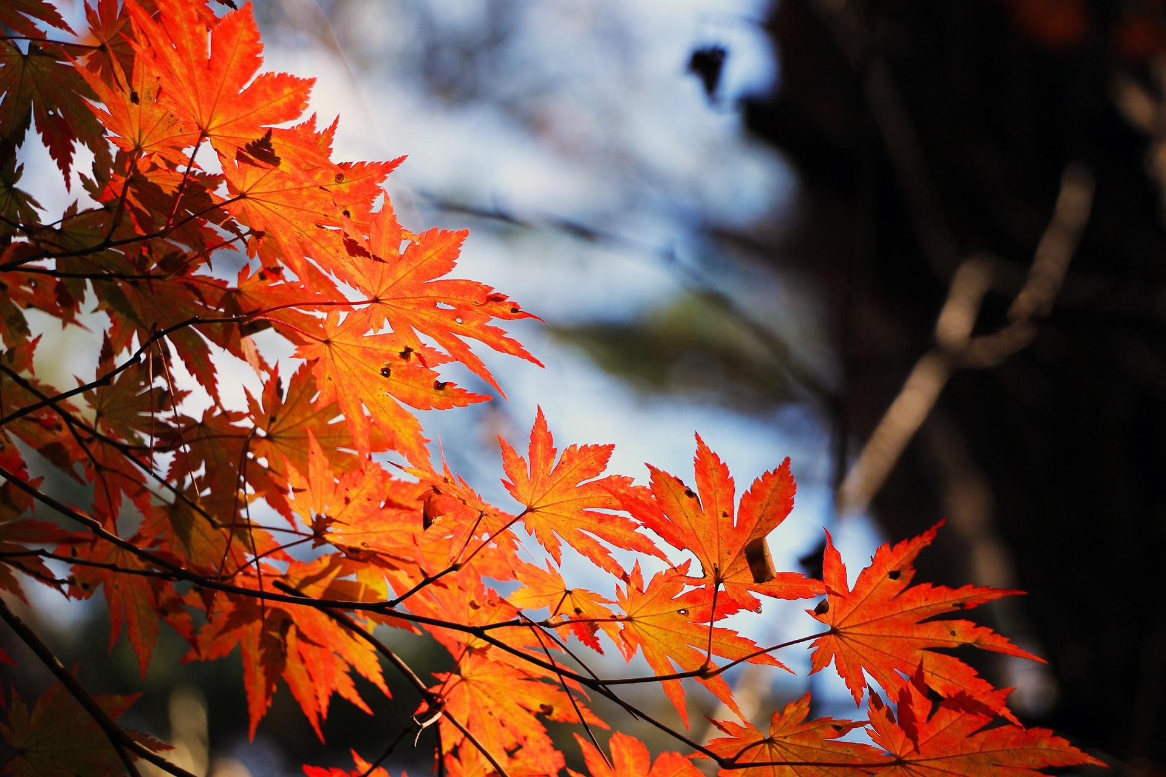  A tree with red leaves  A badger hint: the nature reserve’s badger is called Betty  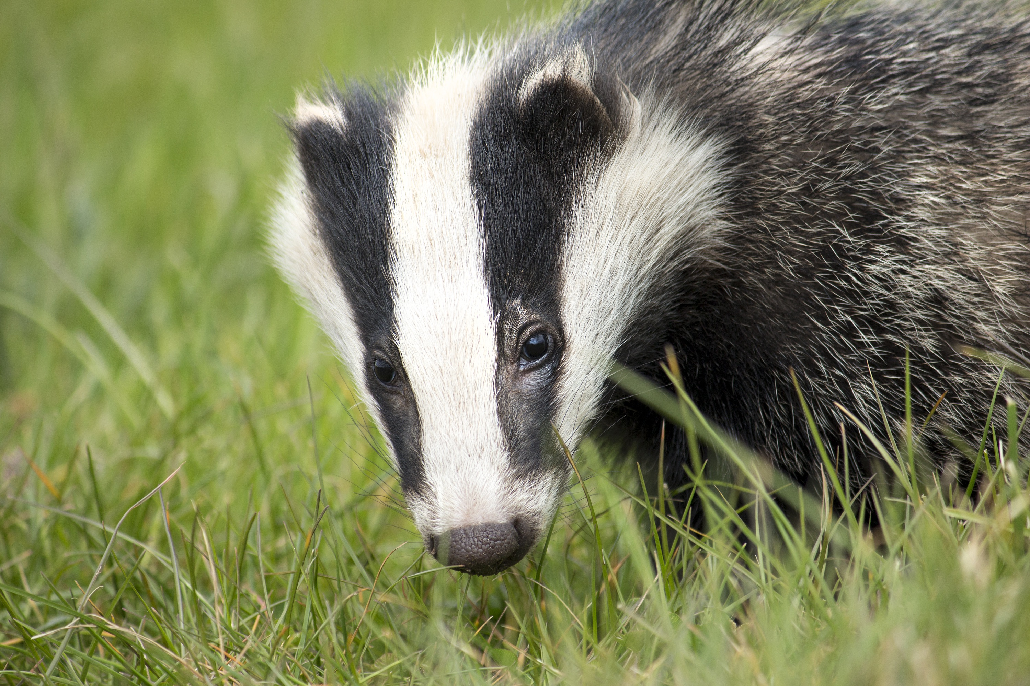  A tree stump  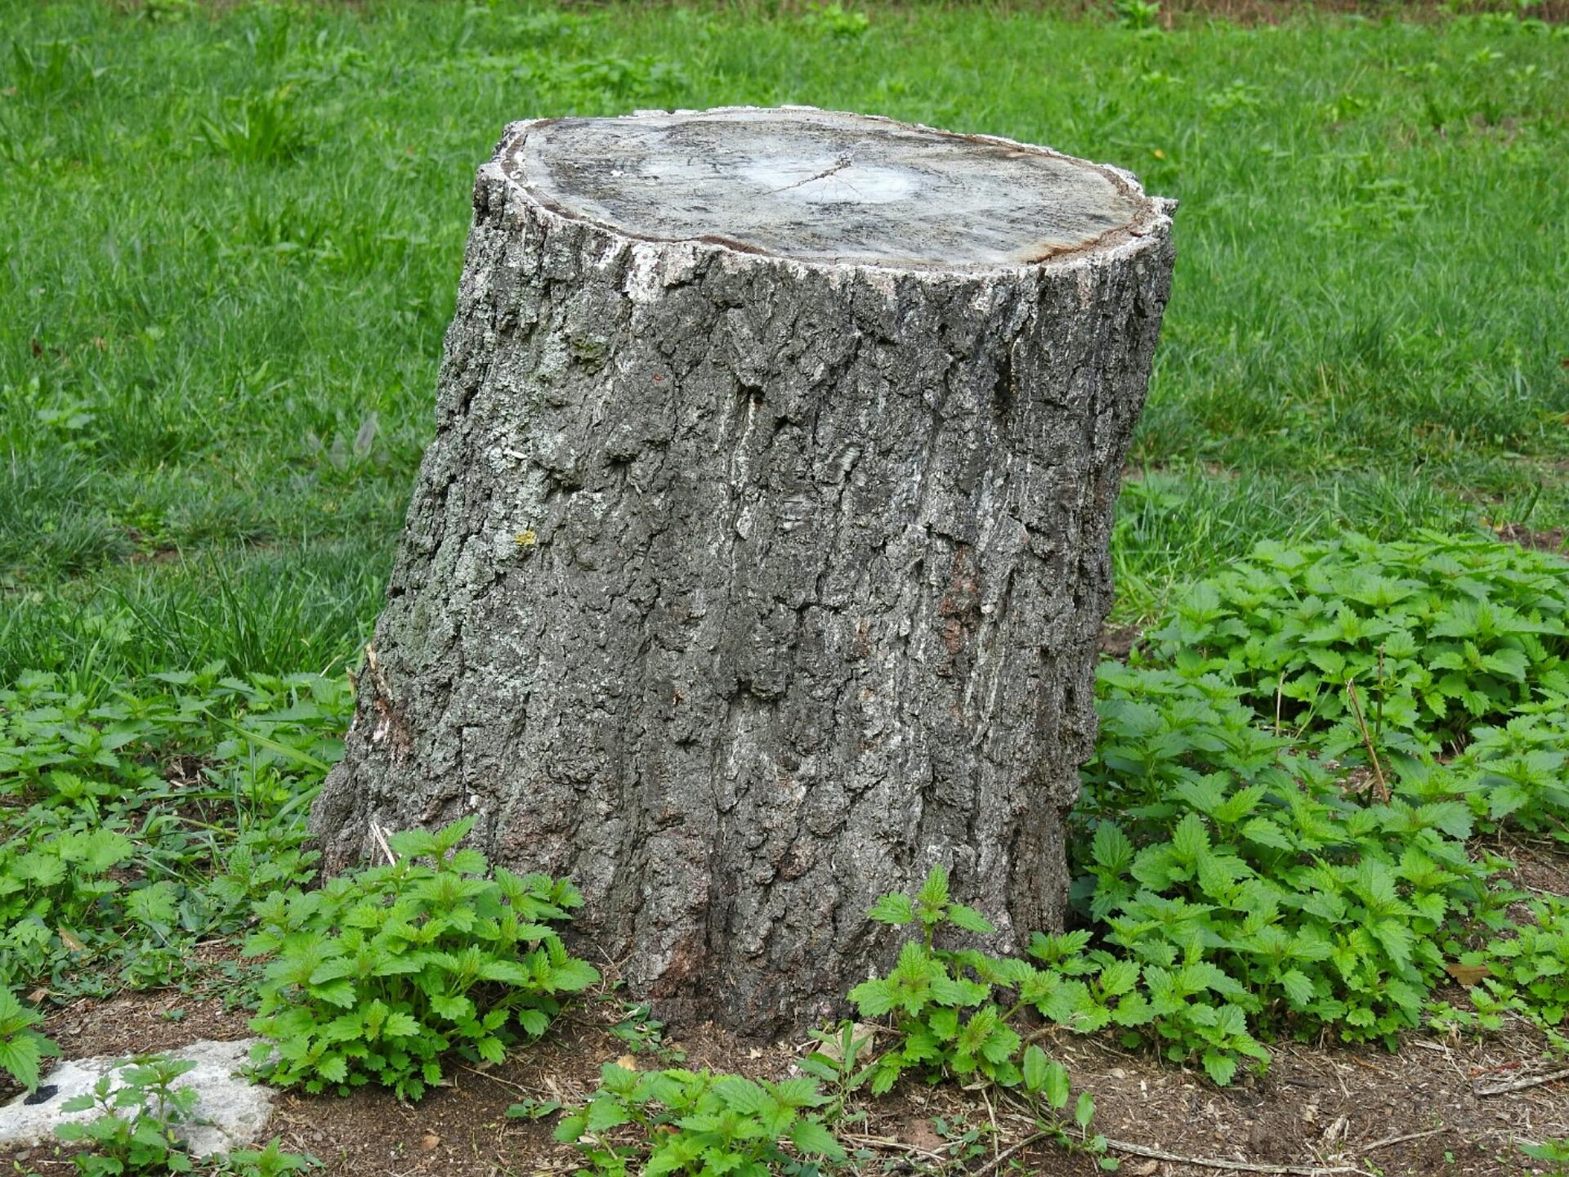
2 |  |  | 3

